App: Green Beat Machine

*Usability Report*

Jerry Webb

I. PARTICIPANTS

Basic demographic information (participant sample size: 5

|  |  |  |  |
| --- | --- | --- | --- |
| Name | Gender | Age | Occupation |
| Jason Gooden | Male | 20 | Undergraduate |
| Tiffany Allen | Female | 21 | Undergraduate |
| Tomi Akingbola | Male | 22 | Undergraduate |
| Tim Woodson | Male | 21 | Undergraduate |
| Caleb Dawkins | Male | 21 | Undergraduate |

II. TASKS

• Record a beat sequence using the beat pad.

• Adjust an 8 track mix using the mixer panel.

III. OVERALL FINDINGS

General issues users encountered:

The purpose of this application is to allow users to quickly and easily record a 4 bar drum loop to save and use later, or to provide an interface to produce a small drum loop on the go. The mixer and midi step sequencer allow for a more powerful tool to customize an place instruments within the mix using individual track pan, volume and mutes. The users enjoyed the customization and convenience of a mini drum sequencer, but experience poor that when playing a large number of sounds in succession on a certain devices. When playing the sequence, tapping the beat pads on beat presented heavy latency, and produced mixed step placements. A suggested feature was the implementation of a file system to allow for the user to load their own sounds. A good suggestion for future releases is the inclusion of a solo button to isolate a specific sample during playback.

IV. SPECIFIC FINDINGS

**Beat-Pad Interface**

Lack of playback indicator for the sequence; users were slightly confused at the state if no sounds were present on the sequencer. Users also wanted a metronome for catching tempo.

*Recommendation: Add a playback indicator and metronome.*

C:\Users\LJ Win 10\Desktop\without metronome and play indicator.tiff 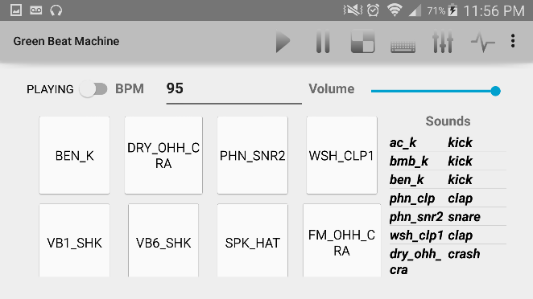

Beat Pad Interface

*after*

Beat Pad Interface

*before*

**Midi Sequencer Indicators:**

It was hard to tell at what point the sequence was playing and which step was which. Playback would also stutter, throwing off the user’s count.

*Recommendation: Add a timeline and time indicator.*

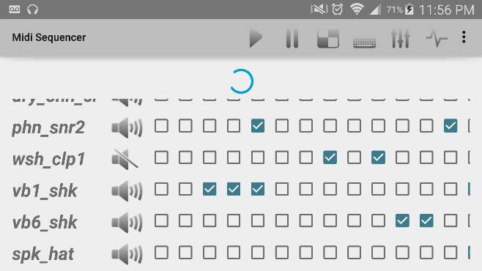 D:\Users\jerrywebb\Pictures\midi with count.tiff

Midi Sequencer

*after*

Midi Sequencer

*before*

**Useless Output Volume Visualizer and Design Scheme**

The users also found that the digital volume meter was not very accurate at displaying the volume levels: too slow and difficult to read. It would often not work correctly, lagging behind the actually output. Small features such as solo and larger pan sliders could have been implemented. A vital improvement would be the overall performance of playback with optimized code.

*Recommendation: Remove the master volume meter to reduce clutter and provide space for other widgets.*

*.*

C:\Users\LJ Win 10\Desktop\usless volume indicator.tiff 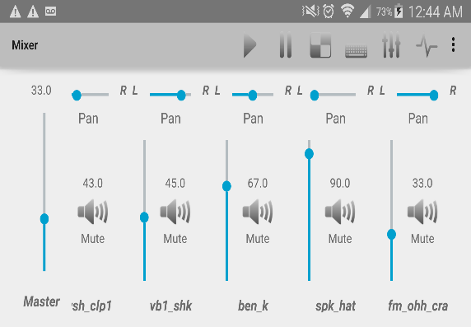

Master channel of Mixer

*after*

Master channel of Mixer

*before*